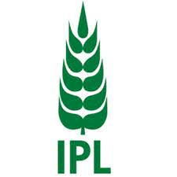
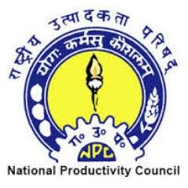
Jaypee University of Information Technology
Solan, 173234

National Conclave on Sustainability, Productivity, and Green Growth

Event: National Conclave on Sustainability, Productivity and Green Growth.

Date: 19th March 2024.
Organised by:
National Productivity Council, DPIIT, Ministry of Commerce and Industry, GOI
AND

Jaypee University of Information Technology

WITH

Indian Potash Limited as Industry Partner

Venue: JAYPEE UNIVERSITY OF INFORMATION TECHNOLOGY

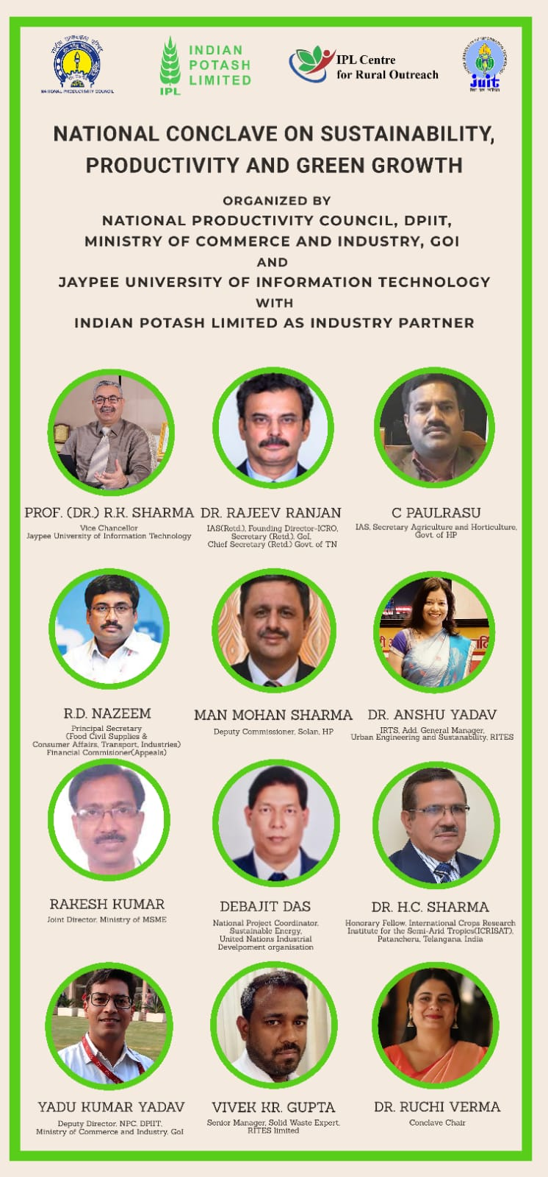

INTRODUCTION

India adds a trillion dollars to its economy every three years. It is poised to become a five trillion-dollar economy very soon. Twin challenges accompany this scorching rate of economic growth. Firstly, extending the economic opportunities for all sections of society in a country with a growing and diverse population such as India. Secondly, addressing the environmental pressures, which, if left unaddressed, will undermine the economic growth plans of the country. Green Growth is seen as a solution to the above problems and consequently is imperative for exploiting the economic opportunities presented to us. Green growth means fostering economic growth and development while ensuring that natural assets continue to provide the resources and environmental services on which our well-being relies. To foster green growth, investment and innovation are essential to underpin sustained growth and create new economic opportunities. Green growth should not be looked upon as a replacement for sustainable development. Instead, it provides a practical and flexible approach for achieving concrete, measurable progress across its economic and environmental pillars while taking complete account of the social consequences of greening the growth dynamic of economies. The focus of green growth strategies is ensuring that natural assets can deliver their full economic potential sustainably. That potential includes providing critical life support services – clean air and water and the resilient biodiversity needed to support food production and human health. Natural assets are not infinitely substitutable, and green growth policies take account of that.

To discuss some of these issues, a Sustainability Conclave was recently organised in Himachal Pradesh. The Jaypee University of Information Technology, along with the National Productivity Council, DPIIT, MoC&I, GoI and Indian Potash Limited as the industry partner, organised the ‘National Conclave On Sustainability, Productivity and Green Growth'. The conclave was held at the Jaypee University of Information Technology, Solan on 19th March 2024 from 10.00 to 17.00 hrs. This conclave brought together practitioners, policymakers, academicians, and researchers to discuss ways in which green growth could ensure enhanced productivity without compromising the country's economic growth targets.

THE ORGANISERS

The main organisers of the Sustainability Conclave were the National Productivity Council in collaboration with the IPL Centre for Rural Outreach and India Potash Limited as the Industry partner. We provide a brief profile of each of the stakeholders below:

National Productivity Council:

The National Productivity Council of India (NPC) was established in the year 1958. It is an autonomous organisation under the Department for Promotion of Industry & Internal Trade, Ministry of Commerce and Industry, Government of India. Besides undertaking research in the area of productivity, NPC has been providing consultancy and training services in areas of Industrial Engineering, Agri-Business, Economic Services, Quality Management, Human Resources Management, Information Technology, Technology Management, Energy Management, Environmental Management etc., to the Government and Public & Private sector organisations. NPC is a constituent of the Tokyo-based Asian Productivity Organisation (APO), an Inter-Governmental Body of which the Government of India is a founding member.

IPL Centre for Rural Outreach:
With an objective to foster rural outreach and capacity development of farmers and youth, India Potash Limited (IPL) has joined hands with the National Productivity Council (NPC), an apex organisation established in 1958 under the Ministry of Commerce & Industry, Govt of India, to generate awareness and consciousness on productivity across the country by providing solutions for improving productivity and competitiveness through different services, namely consultancy, training, action research, evaluation studies etc. IPL has established IPL Centre for Rural Outreach (ICRO) with the involvement and technical expertise of NPC as part of its Corporate Social Responsibility and has launched ICRO Amrit Internship Programme focused on youth productivity for prosperity.

India Potash Limited:
Indian Potash Limited (IPL) is a major player in multiple value chains and inputs in the agricultural sector. The evolution of IPL started sometime before the seeds of the ‘Green Revolution’ got down in the bed of Indian Agriculture. Indian Potash Limited was incorporated under Indian Companies Act with the objective of import-handling, promotion and marketing of Potash in the entire country.
IPL constantly works towards agrarian growth and farmers’ prosperity. The dedicated field work of IPL has led to the acceptance of potash across India, which was unknown to Indian farmers earlier. IPL has a vast network, and its services are coordinated by 15 Regional Offices in various State capitals. This has bestowed an enviable status on IPL to take any agri input or service literally at the doorstep of farmers in the six lakh villages across the country, thereby enabling their growth and development.

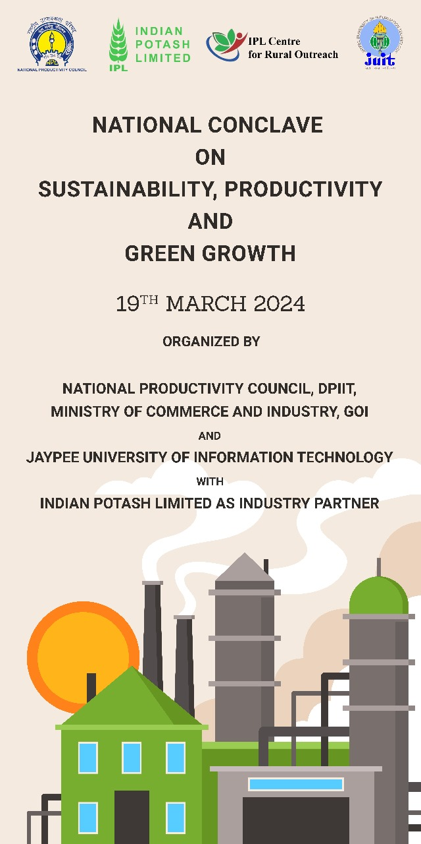
Jaypee University of Information Technology:
- The JUIT was conceived by a joint vision of the Govt of Himachal Pradesh and the Founder Chairman of Jaypee Group Shri Jai Prakash Gaur in 2000. Land was provided on lease by the State Govt and the university was established by Act No 14 of 2002 vide Extraordinary Gazette Notification of the Govt of Himachal Pradesh dated May 23, 2002. The University Grants Commission accorded its approval under Section 2(f) of the UGC Act vide their Letter No. F 9-10/2002(CPP-1) dated 09 Dec 2002. The JUIT is also a member of the Association of Indian Universities (AIU).
- The academic activities of JUIT commenced from July 2002 and currently offer undergraduate B. Tech degree programs in Bioinformatics, Biotechnology, Civil Engineering, Computer Science & Engineering, Electronics & Communication Engineering, Electronics & Computer Engineering and Information Technology.
- Besides B. Tech programs, the university is presently offering M. Tech in Biotechnology, Biotechnology with specialisation in Industrial Biotechnology and Medical Biotechnology, Civil Engineering with specialisation in Structural Engineering, Construction Management and Environmental Engineering, Computer Science and Engineering, Computer Science and Engineering with specialisation in Information Security and Data Science, Electronics and Communication Engineering, Electronics and Communication Engineering with specialization in Internet of Things. M Sc Programs are offered in Biotechnology, and Microbiology.
- Doctoral Phd is offered in Biotechnology, Bioinformatics, Civil Engineering, Computer Science and Engineering, Electronics and Communication Engineering, Humanities and Social Sciences, Mathematics, Physics and Materials Science.
- The University has been twice accredited by NAAC (2011 and 2017).

ABOUT THE EVENT

The National Productivity Council, DPIIT, Ministry of Commerce and Industry, GOI, and Jaypee University of Information Technology with Indian Potash Limited as an Industry Partner organised a National Conclave on Sustainability, Productivity, and Green Growth. The event was held at the Jaypee University of Information Technology on 19th March 2024.
The event commenced with a warm welcome extended to dignitaries and attendees by the Vice-Chancellor JUIT Prof. (Dr.) Rajendra Kumar Sharma. This was followed by the illumination of lamp by the dignitaries. Dr. Ruchi Verma, skilfully introduced esteemed dignitaries after the welcome address by the honourable Vice-Chancellor of JUIT. The esteemed speakers of the Conclave were Shri C Paulrasu IAS, Secretary Agriculture and Horticulture, Govt. of HP, Dr. Rajeev Ranjan Founding-Director-ICRO IAS(Retd.), Shri Man Mohan Sharma, Deputy Commissioner, Solan, HP, Shri Rakesh Kumar, Joint Director, Ministry of MSME, Dr Anshu Yadav, IRTS, Add. General Manager, Urban Engineering and Sustainability, RITES, Yadu Kumar Yadav, Deputy Director, NPC, DPIIT, Ministry of Commerce and Industry, GoI, Debajit Das, National Project Coordinator, Sustainable Energy, United Nations Industrial Development Organisation, Dr H.C. Sharma, Honorary Fellow, (ICRISAT), Former VC of YS Parmar University of Horticulture & Forestry, Vivek Kumar Gupta, Senior Manager, Solid Waste Expert, RITES limited, and Suresh Sharma, Joint Director, Agriculture Department, Himachal Pradesh. Dr. Ruchi Verma acted as the Principal Conclave Chair and was responsible for creating and conducting the conclave.
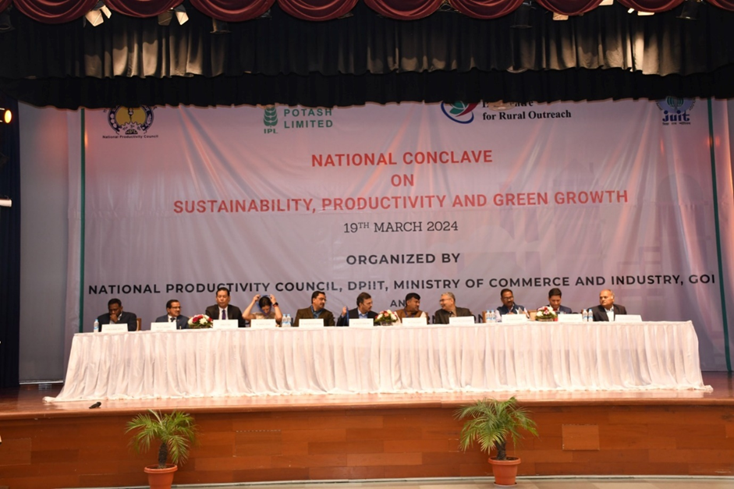
The audience, comprising university officials, faculty members, and students actively participated in the engaging sessions that covered a spectrum of topics critical to sustainable development. Notable presentations were delivered by
Shri C Paulrasu delve into how sustainable agriculture in Himachal Pradesh involves employing environmentally friendly farming methods to meet present food needs without compromising future generations' ability to do the same. It focuses on minimizing adverse effects on soil, water, biodiversity, and nearby communities. Techniques like crop rotation, integrated farm management, zero budget farming, organic farming, and natural farming are utilized to promote sustainability while addressing issues like nitrate leaching and enhancing nutrient sources through innovative approaches such as genetic engineering and renewable energy-based electrolysis.
Sh. Rajeev Ranjan sprinkled wisdom on how sustainable productive green growth emphasizes efficient resource utilization and environmentally sustainable economic growth. Encouraging innovation, promoting sustainable consumption, and fostering collaboration among government, private sector, and communities are crucial for achieving balanced growth. The 5 Ps of sustainability, encompassing People, Planet, Prosperity, Peace, and Partnership, provide a framework for comprehensive sustainable development goals.
Sh. Man Mohan Sharma who shared about sustainable development through renewable energy. It highlights the global shift towards solar, wind and hydro power, and Himachal Pradesh's goals to achieve this. The state aims to harness its hydro potential, promote green products, subsidize solar projects for youth, and develop green panchayats.
Dr Anshu Yadav and Mr Yadu Kr. Yadav who focused on actively promoting green mobility through various initiatives such as advancing ethanol blending targets, supporting research on green ammonia and hydrogen, and implementing the National Electric Mobility Mission Plan with a target of 6-7 million sales of hybrid and electric vehicles annually from 2020 onwards.
Sh. Rakesh Kumar who spoke about the Ministry of MSME and its aims to reduce emissions intensity by 45% by 2030 and achieve net zero emissions from the MSME sector by 2070. They plan to achieve this through initiatives like offering 2% interest subvention on loans up to INR 2 crores, promoting adoption of green technology and clean energy sources, and enhancing operational efficiency, which is expected to benefit 12,000 MSMEs with annual energy savings of 1600 GWh and substantial reductions in carbon emissions. Implementation is facilitated by the Small Industries Development Bank (SIDBI) and involves collaboration with scheduled commercial banks, financial institutions, and non-banking financial companies.
Mr. Debajit Das explained in quite a lucid manner about how India's greenhouse gas emissions predominantly stem from the energy sector, notably coal-based power generation, while agriculture and industrial processes also contribute significantly. To combat this, India has set ambitious goals, including obtaining 50% of its energy from renewables by 2030 and establishing 500 GW of fossil fuel-free capacity, signalling a strong commitment to decarbonization and a greener future.
And finally, Mr Vivek Kr. explained the current state of waste management in India and the goals of Swachh Bharat Mission 2.0 (SBM 2.0). SBM 2.0 aims to make India garbage-free by focusing on waste segregation, collection, processing, and disposal. It also emphasizes remediating old landfills and reducing pollution caused by waste management. He also mentioned about RITES' involvement in providing technical support and project management for SBM 2.0 initiatives.
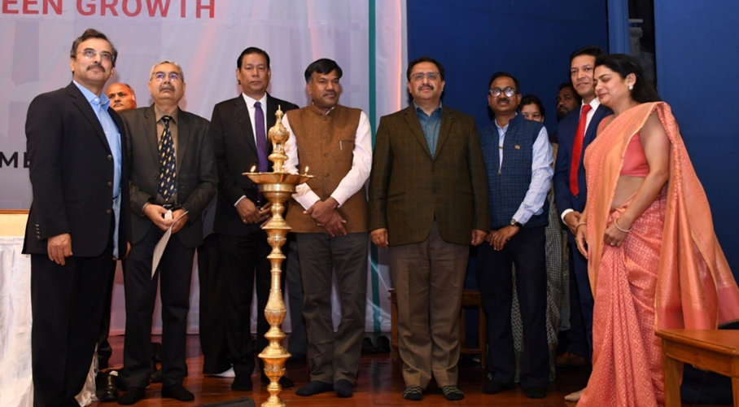
An Ideathon and Case Study competition were also organised in parallel to the sessions of the Conclave. Prizes worth Rs. 20,000 and Rs. 10,000 were awarded to the winners at the end of the conclave by Dr. Rajeev Ranjan and the Vice-Chancellor.
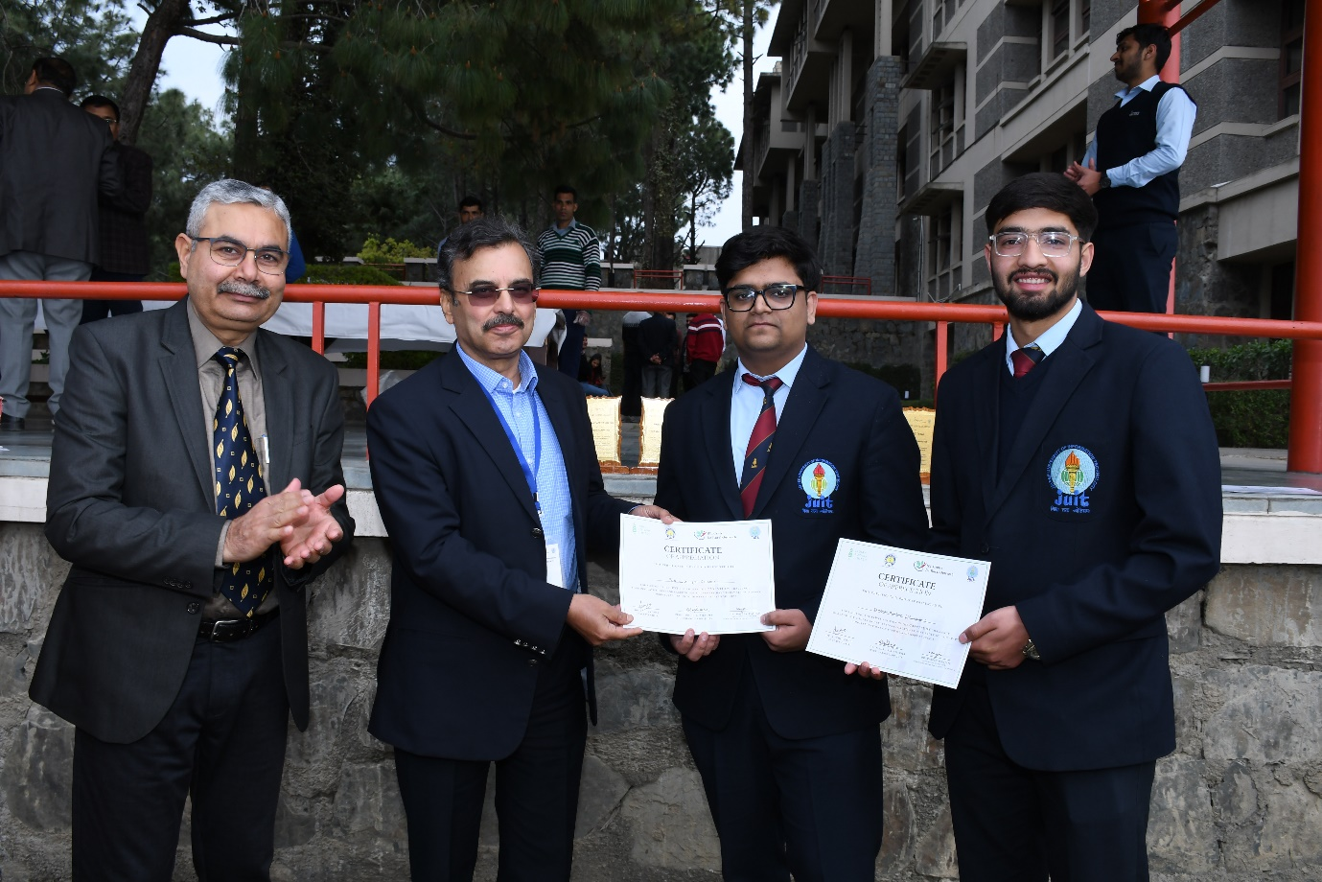

A voters awareness campaign was also conducted by the District Election Office, Solan in collaboration with Jaypee University of Information Technology. It was attended by the Deputy Commissioner, Solan, Sh. Man Mohan Sharma, SDM, Kandaghat, Mr. Siddharth Acharya and other officials.

The success of the National Conclave on Sustainability, Productivity, and Green Growth would not have been possible without the dedicated efforts of student volunteers and the unwavering support of the university management. In the end, the event concluded with a vote of thanks extended by the Vice Chancellor of JUIT, expressing gratitude to all participants and organisers for their contributions towards making the conclave a resounding success.

CONCLUSION

The National Conclave on Sustainability, Productivity, and Green Growth held at Jaypee University of Information Technology showcased a remarkable convergence of expertise, insights, and initiatives aimed at fostering sustainable development. With distinguished dignitaries from various sectors, the event provided a platform for comprehensive discussions on critical topics like sustainable agriculture, green mobility, decarbonization, and solid waste management.

The engaging sessions, complemented by insightful presentations, Ideathon, and Case Study competitions, facilitated active participation from university officials, faculty members, and students, highlighting a collective commitment to addressing environmental challenges. Additionally, the collaboration with the District Election Office for a voters awareness campaign underscored the broader societal engagement and impact of the conclave.

The success of the event owes much to the meticulous planning and execution by the organisers, led by Dr. Ruchi Verma, and the enthusiastic involvement of student volunteers. Their dedication, coupled with the unwavering support of the university management, ensured the conclave's effectiveness in disseminating knowledge, fostering collaboration, and inspiring actionable solutions for a greener and more sustainable future. As the Vice-Chancellor of JUIT aptly conveyed in the concluding vote of thanks, the conclave stands as a testament to the collective efforts and commitments towards achieving sustainable growth and prosperity.

